

Saint Edmund’s Catholic Primary School
‘Together we learn and grow through worship and celebration’

Special Educational Needs and
Disability (SEN/D) policy

Committee responsible for policy | Curriculum & Achievement
Coordinator | Terri Meldon
Approved by Committee/FGB | September 2026
Statutory/Non-statutory | STATUTORY
Frequency of Review | Reviewed Annually alongside the SEND Information Report
Date of next review | September 2027  (review alongside new SEND Inclusion Strategy due December 2026)
Purpose of policy | To fulfil the Governing Body’s role in ensuring the school complies with the SEN code of practice. To enable teachers to support individuals or groups of children who may need additional help to  participate effectively in curriculum and assessment activities.
Consultation | Government documentation  and guidance
Links to other policies | Equalities,  Admissions,  Medical  Behaviour  Accessibility

Introduction
St. Edmund’s Catholic Primary School believe it is every pupil’s right to a purposeful and meaningful education. As set out in the Mission Statement, we want all our children to fulfil their potential by upholding their dignity and valuing them for who they are not what they can do. This policy aims to:
- Set out how our school will support and make provision for any pupil with additional needs or disabilities;
- Explain the roles and responsibilities of everyone involved in providing for pupils with additional needs also defined as SEN/D (special educational needs and disability).

Objectives
The objectives of this policy are:
- To ensure that children who present with SEN/D are identified early through the graduated approach;
- To use our school and local offer to seek support and guidance from outside professionals to ensure the highest quality provision for each child;
- To ensure all children have access to a rich and challenging curriculum.

Legislation and guidance
This policy and our SEN/D information report are based on the statutory Special Educational Needs and Disability (SEN/D) Code of Practice (January 2015) and the following legislation:
- Part 3 of the Children and Families Act 2014, which sets out schools’ responsibilities for pupils with SEN/D and disabilities;
- The Special Educational Needs and Disability Regulation 2014, which sets out schools’ responsibilities for education, health and care (EHC) plans, SEN/D co-ordinators (SEN/DCOs) and the SEN/D information report.

Inclusion
Our faith instils a strong sense of social justice and therefore we aim to create a learning environment and school community where no groups feel alienated, discriminated against or marginalised. Our school aims to ensure equality of opportunity and access to the curriculum for all pupils. We do this by:

- Being flexible and adaptive in our approach to teaching and learning;
- Recognising that relationships are the foundation for all learning;
- Responding early to the diverse range of needs our children may display;
- Identifying strengths and good qualities in each child and striving to remove or reduce barriers to learning.

We recognise the fact that children:
- have different educational and behavioural needs and aspirations;
- require different strategies for learning;
- acquire, assimilate and communicate information at different rates;
- need a range of different teaching approaches and experiences.

Special Educational Needs and/or a Disability (SEN/D)
A child is recognised as having SEN/D if they have a learning difficulty or disability which calls for special educational provision to be made for her or him. We recognise that any child may present with special or additional needs at some time in their life.

The Special Educational Needs and Disability (SEN/D) Code of Practice (Sept 2014, p15) defines SEN/D as:

A child of compulsory school age or a young person has a learning difficulty or disability if he or she:
- Has a significantly greater difficulty in learning than the majority of others of the same age, or
- Has a disability which prevents or hinders him or her from making use of the facilities of a kind generally provided for others of the same age in mainstream schools or mainstream post-16 institutions
CATEGORIES of Special Educational Need

1. Communication and Interaction
- Speech, language and communication difficulties
- Autism Spectrum Disorders

- Cognition and Learning
    - General Learning Difficulties ( which may include those with moderate, severe or profound difficulties)
    - Specific Learning Difficulties (e.g. dyslexia, dyscalculia)

- Social, emotional & mental health difficulties
    - Social and mental difficulties which may manifest themselves in different ways
    - ADD
    - ADHD
    - Attachment disorder

- Sensory and Physical Difficulties
Some children may require SEN/D provision if their disability prevents or hinders them from making full use of educational facilities.
  - Hearing Impairment
  - Visual Impairment
  - Physical impairment/disability
  - Multi – sensory impairment

September 2026 Update – Please note that new SEND reforms suggest that categories of Need will be re-defined and considered more broadly in terms of the diagram on Page 4 of this policy.
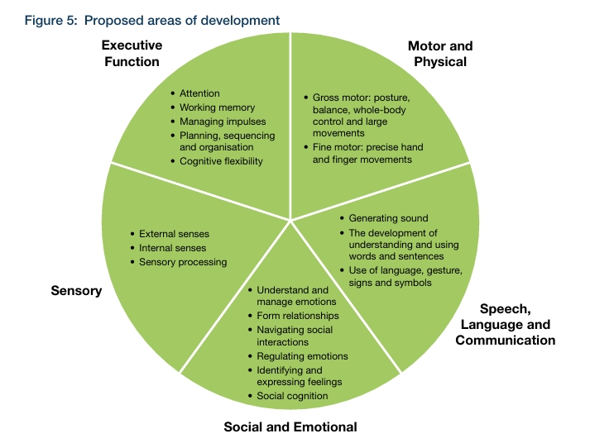

Roles and responsibilities

The role of the Class teacher:
We recognise that the main responsibilities of every class teacher are:
- providing ‘quality first’ teaching that is appropriate to the need of each individual child;
- working closely with parents/carers, learning support assistants, teaching assistants, SEN/DCo, specialist staff, outside agencies and other professionals to ensure appropriate provision and intervention that is closely linked to classroom teaching;
- working with the SEN/DCo, parents/carers and pupil to review individual support plans and to ensure the progress and development of each pupil, ensuring they follow the SEN/D policy;
- to report to parents/carers termly, via a child’s individual support plan, using a child centred approach, on what is working well and what needs to change.

The role of the Special Educational Needs Co-ordinator (SEN/DCo):
We recognise that SEN/DCo’s responsibilities are as follows:
- managing the day-to-day operation of the policy;
- working with the head teacher and SEN/D governor to determine the strategic development of the SEN/D policy and provision;
- to plan and coordinate specific provision made to support individual pupils with SEN/D, including those who have EHC plans;
- to advise on the graduated approach to identifying and providing support for pupils with SEN/D;
- to manage support staff
- to advise on the deployment of the school’s delegated budget and other resources to meet pupils’ needs effectively;
- to be the point of contact for external agencies, especially the local authority and its support services;
- liaise with potential next providers of education to ensure that pupils and their parents/carers are informed about options and a smooth transition is planned;
- to work with the head teacher and governing body to ensure that the school meets its responsibilities under the Equality Act 2010 with regard to reasonable adjustments and access arrangements;
- to ensure the school keeps the records of all pupils with SEN/D up to date.
- To coordinate and manage referrals to outside agencies.
- To support teachers with the management of individual support plans.
- To signpost parents and teachers to additional support and advice.
- To meet with outside professionals to discuss provision and individual targets for children on the SEN register.
- To manage and maintain the wave 3 (SEN register) and Wave 2 (additional short term / time-limited provision) registers.
- To coordinate and write EHC application requests to a child’s local authority

The role of the governing body
The governing body aims to secure the necessary provision for any pupil identified as having special educational needs. The governors work closely with the head teacher and SEN/DCo to determine the strategic development of the SEN/D policy and provision.

The governing body has decided that children with special educational needs will be admitted to the school in line with the school’s agreed admissions policy. Our school’s named governor for SEN/D is Mr C Pandole.

The Role of Teaching and Learning Support Assistants
• To support a range of needs within our school and show an awareness of how best to support vulnerable children.
• To aid pupils to learn effectively in group situations and individually, for example, by clarifying and explaining instructions, adjusting work to meet needs as required whilst encouraging independence and delivering targeted support and intervention.
• To work with the class teacher and Inclusion team to devise strategies to support whole class learning objectives.
• To establish a supportive relationship with pupils and develop/promote self-esteem where appropriate.
• To assist in the delivery of interventions to support learning for specific needs (SEN support, EAL. PPG, all groups of pupils)
• To support children to achieve their outcomes as outlined in an Educational Health Care Plan or an Individual Support Plan.
• To assist with supervision of child/ren in class, between classes and during breaks.
• To prepare and ensure resources are available to support learning.
• To carry out administrative tasks as required
• To provide regular feedback about pupils’ progress to the teacher and other professionals supporting the child.

The role of the Headteacher
We recognise that the headteacher will:
- work with the SEN/DCo and SEN/D governor to determine the strategic development of the SEN/D policy and provision in the school;
- have overall responsibility for the provision and progress of learners with SEN/D.

Partnership with parents/carers
At all stages of the graduated approach, the school aims for parents and carers to be active contributors to plans and provision for their child. The school takes account of the wishes, feelings and knowledge of pupils and parents/carers at all stages. The school encourage parents/carers to be pro-active in raising any questions or concerns regarding provision for their child.

The school must meet parents/carers at least once a term, for at least 20 minutes, to discuss the progress of their child who has been identified as presenting with SEN/D. These meetings will focus on the child’s individual support plan. Parents and carers’ views and contributions are an integral part of the graduated approach.

Assessment
Early identification of additional needs is vital and is the first step to providing additional support. Any individual who knows the child well has a duty to raise any concerns to the appropriate professional (school or health professional). In the first instance, concerns should be raised by or to the class teacher. At St Edmund’s, part of our graduated approach uses ‘waves’ to help allocate provision based on needs:

Wave 1 - children make expected progress and their needs can be met through inclusive ‘quality first’ teaching and the school’s universal offer;

Wave 2 - in addition to wave 1 provision, children require targeted or structured interventions - these interventions are short term and time limited; they are usually for one specific area of learning developmental or social / emotional support

Wave 3 - In addition to wave 1 and 2 provision, children require highly personalised support and interventions - these are likely to be long term. The provision is over and above the school’s ordinary offer and can often require additional support from outside professionals e.g.
an educational psychologist.

Children at Wave 3 fall within the definition of SEN/D and are therefore entered onto the school’s SEN/D register. All children on the SEN/D register have individual support plans.

The class teacher must review the support plan at least once a term with the parents/carers. The individual support plan is developed using a child-centred approach. Further details on our graduated approach can be found in our SEN/D information report.

The Governing Body should review this policy annually and consider any amendments in light of the annual review findings or government initiatives.

Inclusion Manager and designated SEN/DCo: Miss T Meldon

Named SEN Governor: Mr C. Pandole

